TopCoder Registration Site Handle Validation Upgrade Deployment Guide

Revision History
Author | Revision Number | Date
sokol | 1.0 | 05/30/2012

Deployment Instructions 3
1. Organization of Submission 3
2. Application Setup 3
2.1 Ant .Properties File 3
2.2 Build Scripts Setup 4
3. Database Setup 4
4. Deployment Instructions 4
5. Starting 7
6. Verification 8
7. Resource Contact List 9

Deployment Instructions

Organization of Submission

The content of submission follows directory structure provided below:

docs

Contains this document.

src

Contains the sources of TopCoder Registration Site Handle Validation Upgrade.

test_files/deploy/sql

Contains the SQL script for creating invalid handles table and initial data

test_files/deploy/updated_src

This directory contains updated TC web sources.

NOTE: Other resources not mentioned here are not used for deploying and used only for local testing purpose.

Application Setup

The application is expected to be deployed to Topcoder VM with the following environment:

Java
JBoss
VM
JSON
XML
SQL
Informix 11.0
.

'

Ant .Properties File

Property Name | File property is stored | Example Setting

Build Scripts Setup

Database Setup
Assumed that Informix database is running on your Topcoder VM.
- Execute test_files/deploy/sql/ddl.sql to create invalid_handles table in common_oltp database and create required synonymous.
- Execute test_files/deploy/sql/invalidHandles.sql to populate invalid_handles table with predefined invalid handles
NOTE: To drop created table use test_files/deploy/sql/drop.sql script.

Deployment Instructions
All operations performed on VM under tc login.
- Copy sources from src/java/main folder to /home/tc/web/src
- Copy updated sources from test_files/deploy/updated_src folder to /home/tc/web/src
- Deploy updated tc-reg module to JBOSS server with command:
ant -f build_tc.xml deploy-reg from /home/tc/web directory
- Restart JBOSS server
- jbb
- ./kill.sh (if it’s running)
- ./start.sh
- After JBOSS restart update Topcoder Query Tool
  - Go to http://tc.cloud.topcoder.com/query/query
  - First time you will be redirected to /tc page, login there as heffan/password
  - After login you will be on Query Tool Page
  - Go to ‘Transactional’
Routine for creating command and query in Query Tool:
  - Create new command command by clicking “New Command” on the left panel.
  - Input command name ‘invalid_handle’ and select ‘Util’ group. After click ‘Save’.
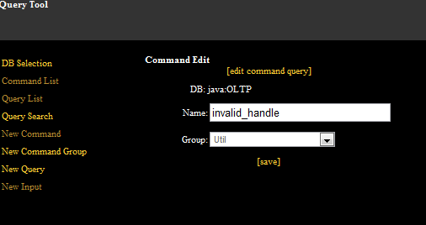
  - Create new query by clicking ‘New Query’ on the left panel.

  - Input query name ‘invalid_handle’ and paste such query text and after click ‘Save’:
select ih.invalid_handle as handle
from 'informix'.invalid_handles ih
where ih.invalid_handle = '@handle@'
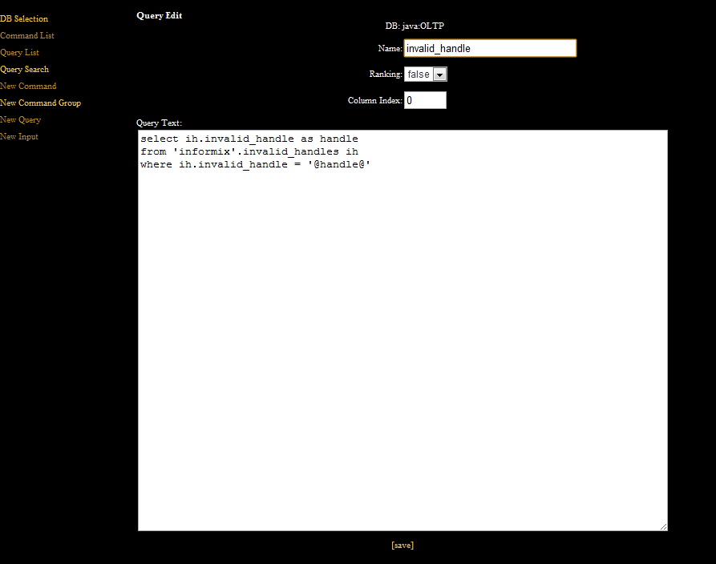
  - Create new input by clicking ‘New Input’ on the left panel.
  - Input such values and click ‘Save’: Description:“invalid handle”, Code:“handle”, Data Type: String.
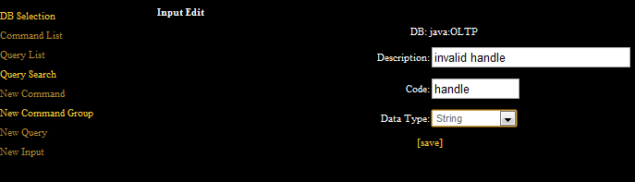
  - Now we need to modify ‘invalid_handle’ query input parameters. Click ‘Query List’ and click ‘[edit]’ near ‘invalid_handle’ query name.
  - After click ‘[edit query input]’ at the top of query edit screen.
  - Select ‘handle’ input parameter from list and click ‘[add]’. Input parameter will be added to query.
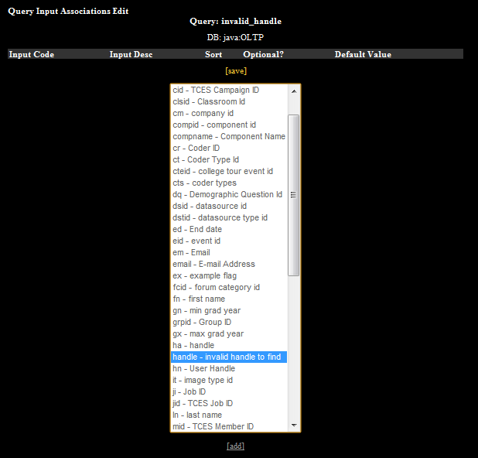
  - Now we need to add query ‘invalid_handle’ to command ‘invalid_handle’. Click ‘Command List’ and click ‘[edit]’ near ‘invalid_handle’ command name.
  - Click ‘[edit command query]’ at the top of command edit screen.
  - Select query ‘invalid_handle’ from list and click [add]. Query will be added to command.
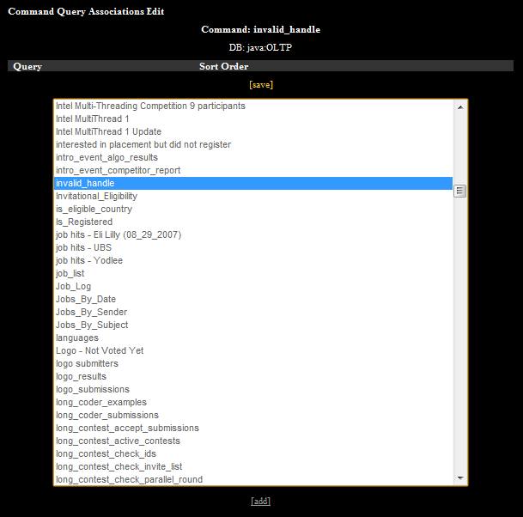

  - Now we need to add another command ‘invalid_handle_all’ with query ‘invalid_handle_all’ and no input parameters. Please follow the same routine as in 5)-16) with two exceptions there is no need to create input parameter and query text should be:
select ih.invalid_handle as handle
from 'informix'.invalid_handles ih

Starting

JBOSS server is already started, so you can easily go to http://tc.cloud.topcoder.com/tc to check it.

Verification
Assumed that your operation system hosts file contains such row:
50.17.49.228 tc.cloud.topcoder.com tcs.cloud.topcoder.com
where IP address is address of assigned to you VM.
You can check working fully configured VM at 50.17.49.228.

- Open Registration page: http://tc.cloud.topcoder.com/reg, check ‘on Topcoder’ box and click ‘Submit’.
- Input all required fields for registration, except ‘Username’.
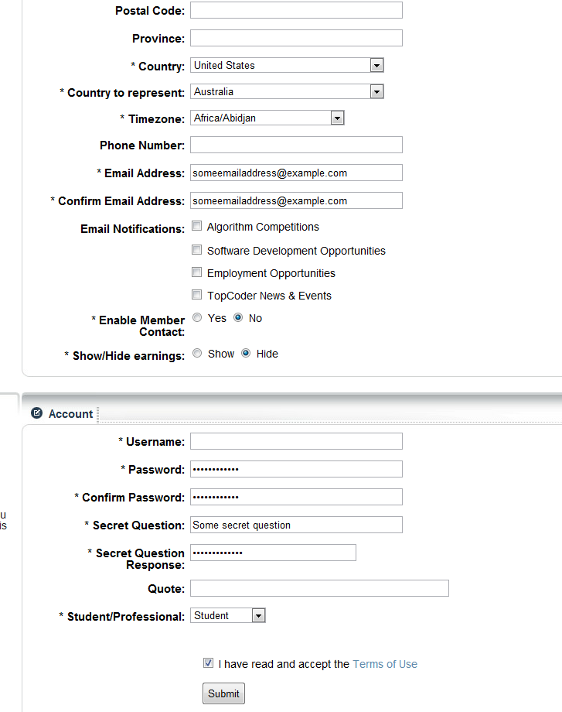
- Now you can try to input some usernames that contains invalid offensive words like ‘a551’, ‘101anal101’, ‘__ass__’, ‘asses’ and Submit form:
- 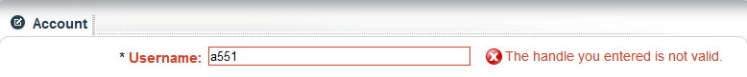
- 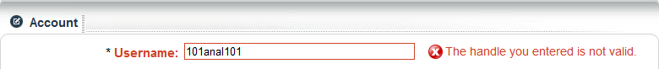
- 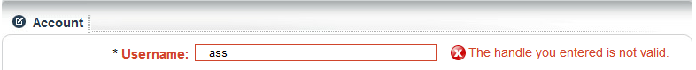
- 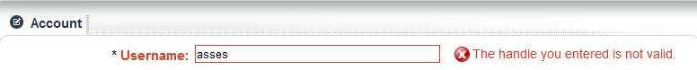
- If you enter username for example ‘brushit’ that contains offensive word but doesn’t start with numbers or underscore user will be created successfully.

Resource Contact List

Name | Resource Email
sokol

